INVENTORY MANAGEMENT
@CREATIVITY THINK (9483175986/7019689991)

ABSTRACT:
Inventory Management is a dashboard-based web application designed to streamline product tracking, stock level monitoring, reorder alerts, and reporting functionalities. It helps retail shops, warehouses, and supply-chain units maintain accurate stock levels and prevent shortages with automated low-stock alerts. The system offers role-based access, supplier management, inventory logs, and exportable analytics reports. Using Django and Django Rest Framework for backend operations and React with Chart.js for data visualization, the platform provides a modern, scalable, and structured solution for inventory operations..

INTRODUCTION OF THE PROJECT:
Effective inventory management is crucial for retail and warehouse operations, yet many organizations still depend on spreadsheets or manual tracking methods. These inefficient systems result in stock inaccuracies, delayed reorder actions, and missing data logs. Inventory Management solves these issues through a structured digital platform offering real-time stock level insights, reorder notifications, product management, supplier tracking, and exportable reports. The backend ensures secure and accurate data handling, while the frontend presents a clean, interactive dashboard designed for operational ease and efficiency..

PROJECT OBJECTIVES:

• Provide a centralized dashboard for product and stock management.
• Track inventory levels and notify users of low-stock or reorder requirements.
• Enable users to add, edit, update, and search products efficiently.
• Offer exportable inventory and usage reports.
• Allow administrators to configure warehouse settings and suppliers.
• Maintain accurate logs of inventory changes and user actions.
• Support role-based access control for users and admins.
• Present real-time charts and analytics for informed decision-making.

PROBLEM OF THE STATEMENT:
Traditional inventory tracking systems relying on manual input or outdated tools cause frequent stock discrepancies, delays in reordering, and lack of visibility into stock usage patterns. Businesses face challenges in maintaining real-time stock levels, recording historical logs, and generating accurate reports. Inventory Management addresses these issues by providing an automated and reliable digital solution that ensures updated stock information, reduces human error, and delivers operational transparency through dashboards and exportable analytics..

MOTIVATION OF THE PROJECT:
• To reduce stock mismanagement across retail and warehouse environments.
• To automate the process of tracking low-stock items and reorder levels.
• To avoid dependence on manual spreadsheets and fragmented tools.
• To enable accurate logging and reporting of inventory usage.
• To provide a scalable solution adaptable across industries.
• To ensure efficient stock operations with minimal human error.

BLOCK DAIGRAM OF PROJECT:

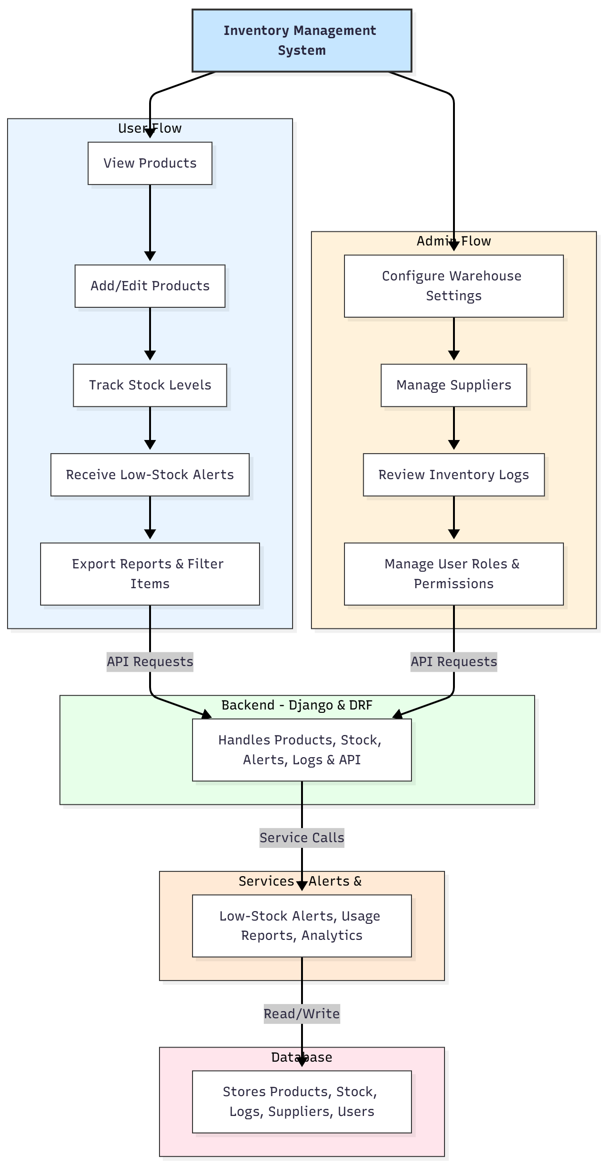

WORKING OF THE PROJECT:
The system begins with users logging into the dashboard using their assigned roles. Users can add and edit products, monitor stock levels, search inventory by category, and export reports. The system continuously checks stock quantities and triggers low-stock or reorder alerts whenever thresholds are reached. Administrators configure warehouse settings, manage suppliers, review activity logs, and control user permissions. All operations are processed through Django REST APIs, ensuring data integrity and smooth communication between frontend and backend. React renders dashboard components, while Chart.js provides real-time graphical analytics. Inventory data, stock logs, and user activity are securely stored in a SQL-based database..

SOFTWARE REQUIREMENT:
- Backend:
  - Python 3.x
  - Django
  - Django REST Framework
  - SQLite/PostgreSQL
- Frontend:
  - Node.js and npm
  - React.js
  - Axios
- Development Tools:
  - Visual Studio Code
  - Postman (for testing APIs)
  - Git/GitHub (for version control)
- Server/Deployment (Optional):
  - Gunicorn, Nginx, or Heroku/AWS for hosting

ADVANTAGES OF THE PROJECT:

• Real-time tracking of product stock levels.
• Automated low-stock and reorder alerts.
• Exportable inventory and usage reports.
• Accurate logging of stock updates and user actions.
• Admin control over warehouse settings and permissions.
• Visual dashboards for quick insights.
• Highly scalable for retail chains and warehouses.
• Reduces manual inventory errors significantly.

APPLICATIONS OF THE PROJECT:
• Retail stores and supermarkets
• Warehouses and distribution centers
• Manufacturing units
• Supply-chain operations
• Pharma and medical stores
• Automotive parts stores

REFERENCES:

- Django REST Framework Documentation — Django Software Foundation. Django Documentation. Available: https://docs.djangoproject.com/
- Django REST Framework. DRF Documentation. Available: https://www.django-rest-framework.org/
- React. React Official Documentation. Available: https://reactjs.org/docs/getting-started.html
- Redux. Redux Documentation. Available: https://redux.js.org/introduction/getting-started
- PostgreSQL Global Development Group. PostgreSQL Documentation. Available: https://www.postgresql.org/docs/
- MySQL. MySQL Reference Manual. Available: https://dev.mysql.com/doc/
- Git. Git Documentation. Available: https://git-scm.com/doc
- Node.js. Node.js Documentation. Available: https://nodejs.org/en/docs/
- Axios. Axios Documentation. Available: https://axios-http.com/docs/intro
- Socket.io Documentation – https://socket.io/docs/

